Lab 9 k230705

Code Workout 1

(a)
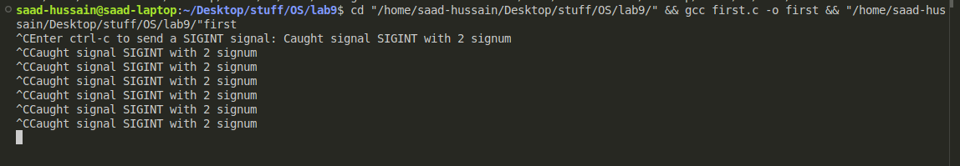
(c)
(e)
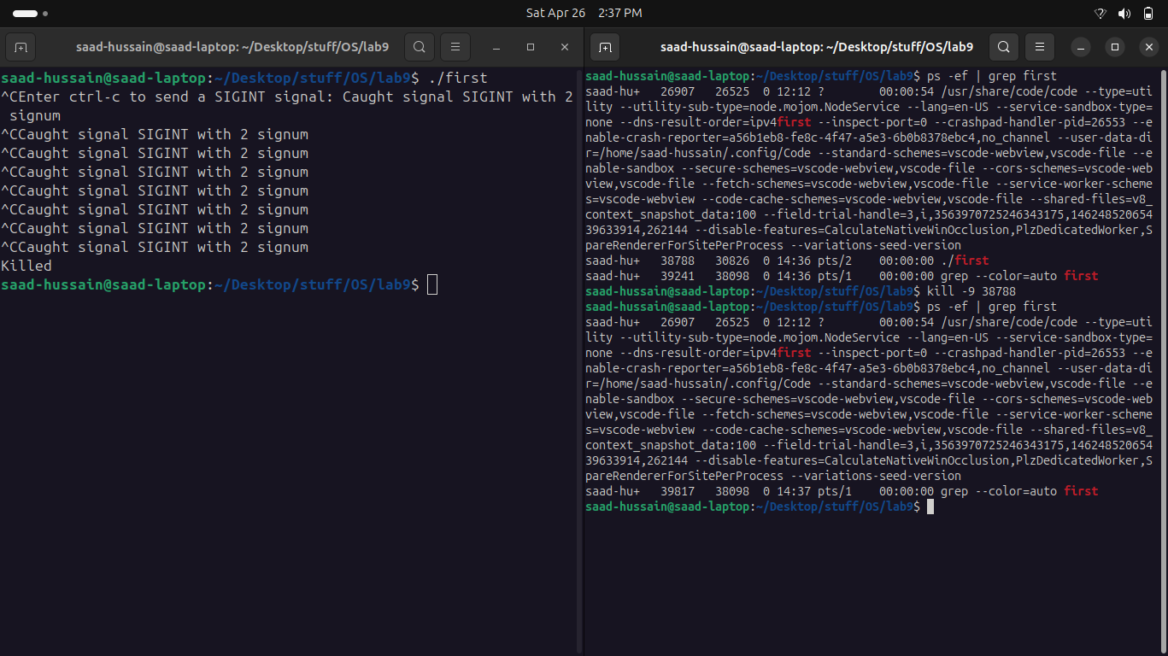

(f)
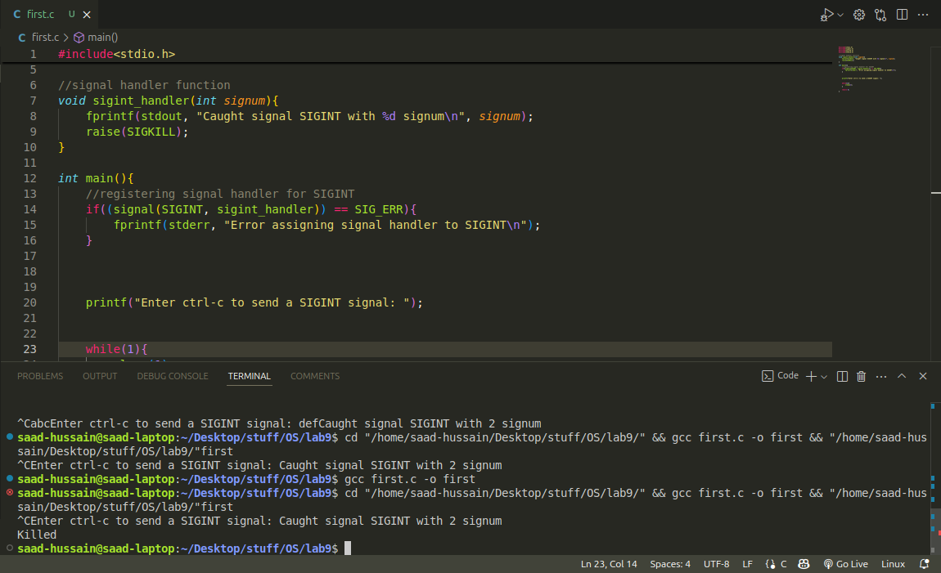

(g)
#include<stdio.h>
#include<signal.h>
#include<unistd.h>
#include<stdlib.h>

void my_handler(int signum){
printf("Caught user defined signal SIGUSR1\n now terminating program\n");
exit(0);
}

//signal handler function
void sigint_handler(int signum){
fprintf(stdout, "Caught signal SIGINT with %d signum\n", signum);
if((signal(SIGUSR1, my_handler)) != SIG_ERR){
kill(getpid(), SIGUSR1);
}
}

int main(){
//registering signal handler for SIGINT
if((signal(SIGINT, sigint_handler)) == SIG_ERR){
fprintf(stderr, "Error assigning signal handler to SIGINT\n");
}

printf("Enter ctrl-c to send a SIGINT signal: ");

while(1){
sleep(1);
}

return 0;
}

Code Workout 1(a)

